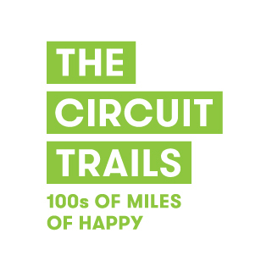
Dear (Municipal Official)

Greater Philadelphia is the proud home of the much-acclaimed Circuit Trails, a vast regional network of hundreds of miles of multi-use trails that is growing in size each year. The Circuit Trails connects our local communities, providing endless opportunities for recreating and commuting.

The (proposed) __________ Trail located in your community (is/will be) an important link in the Circuit that will only increase in value as a recreational and transportation asset as more of the network is connected. Which is why I write to ask you to publicly support the timely completion of 500 miles of Circuit Trails by 2025 in accordance with the region’s transportation infrastructure plan.

The Circuit Trails network, when completed, will total over 750 miles throughout the Greater Philadelphia area including five counties in Pennsylvania and four counties in New Jersey. In the realm of transportation infrastructure, the investment to accomplish the Circuit Trails network is small, but the benefits to your community residents are huge.

We need your support to make the Circuit Trails 750 mile network a reality. Please schedule the attached resolution for adoption at one of your public meetings urging the completion of 500 miles of Circuit Trails by 2025 region-wide.

If you have any questions, if you would like a presentation to your members at either an executive or public meeting, please don’t hesitate to ask.

Your voice matters enormously!

Thank you.

Sincerely,

Your Name

C/o Sarah Clark Stuart, Bicycle Coalition of Greater Philadelphia
1500 Walnut St., Ste. 1107
Philadelphia, PA 19102
sarah@bicyclecoalition.org
www.circuittrails.org

